CSE 3241 Project Checkpoint 04 – Functional Dependencies and Normal Forms
Names Cole Taglione, Om Kurkure, Mitchell Zahner, Sayan Bisi Date 4/1/2025
In a NEATLY TYPED document, provide the following:
- Provide a current version of your ER Diagram and Relational Model as per Project Checkpoint 03. If you were instructed to change the model for Project Checkpoint 03, make sure you use the revised versions of your models.
ER Diagram:
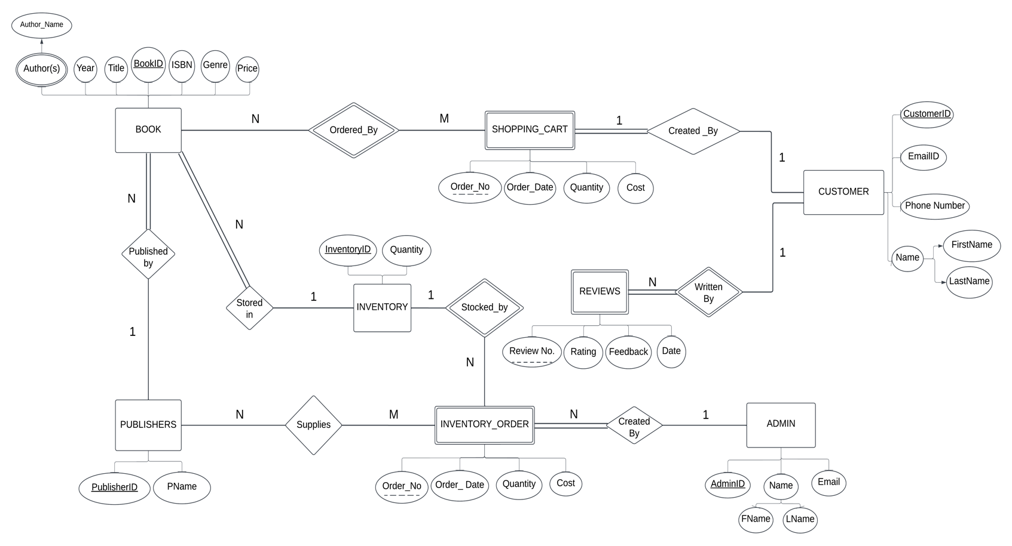
Relational Model:
ADMIN(AdminID#, FirstName, LastName, Email)
INVENTORY_ORDER(Order_No#, Order_Date, InventoryID^{(FK)}, AdminID^{(FK)}, BookID^{(FK)}, Quantity, Cost)
ADMIN_ORDERS(Order_No#^{(FK)}, AdminID^{(FK)})
BOOK(BookID#, PublisherID^{(FK)}, InventoryID^{(FK)}, Title, Year, Genre, ISBN, Price)
ORDERED_BY(Order_No#, BookID^{(FK)})
PUBLISHERS(PublisherID#, PName)
SUPPLIES(Order_No^{(FK)}, PublisherID^{(FK)})
New Relation added after examining Functional Dependencies in old schema
BOOKS_AUTHOR(BookID#^{(FK)}, Author_Name)
INVENTORY(InventoryID#, Quantity)
CUSTOMER(CustomerID#, FirstName, LastName, Email, Phone_Number)
SHOPPING_CART(Order_No#, Order_Date, BookID^{(FK)}, Quantity, Cost)
CUSTOMER_ORDERS(Order_No^{(FK)}, CustomerID^{(FK)})
REVIEW(Review_No#, CustomerID^{(FK)}, Rating, Feedback, Date)
CUSTOMER_BOOKS(CustomerID#^{(FK)}, BookID#^{(FK)}, Title, ISBN)

Old Schema:

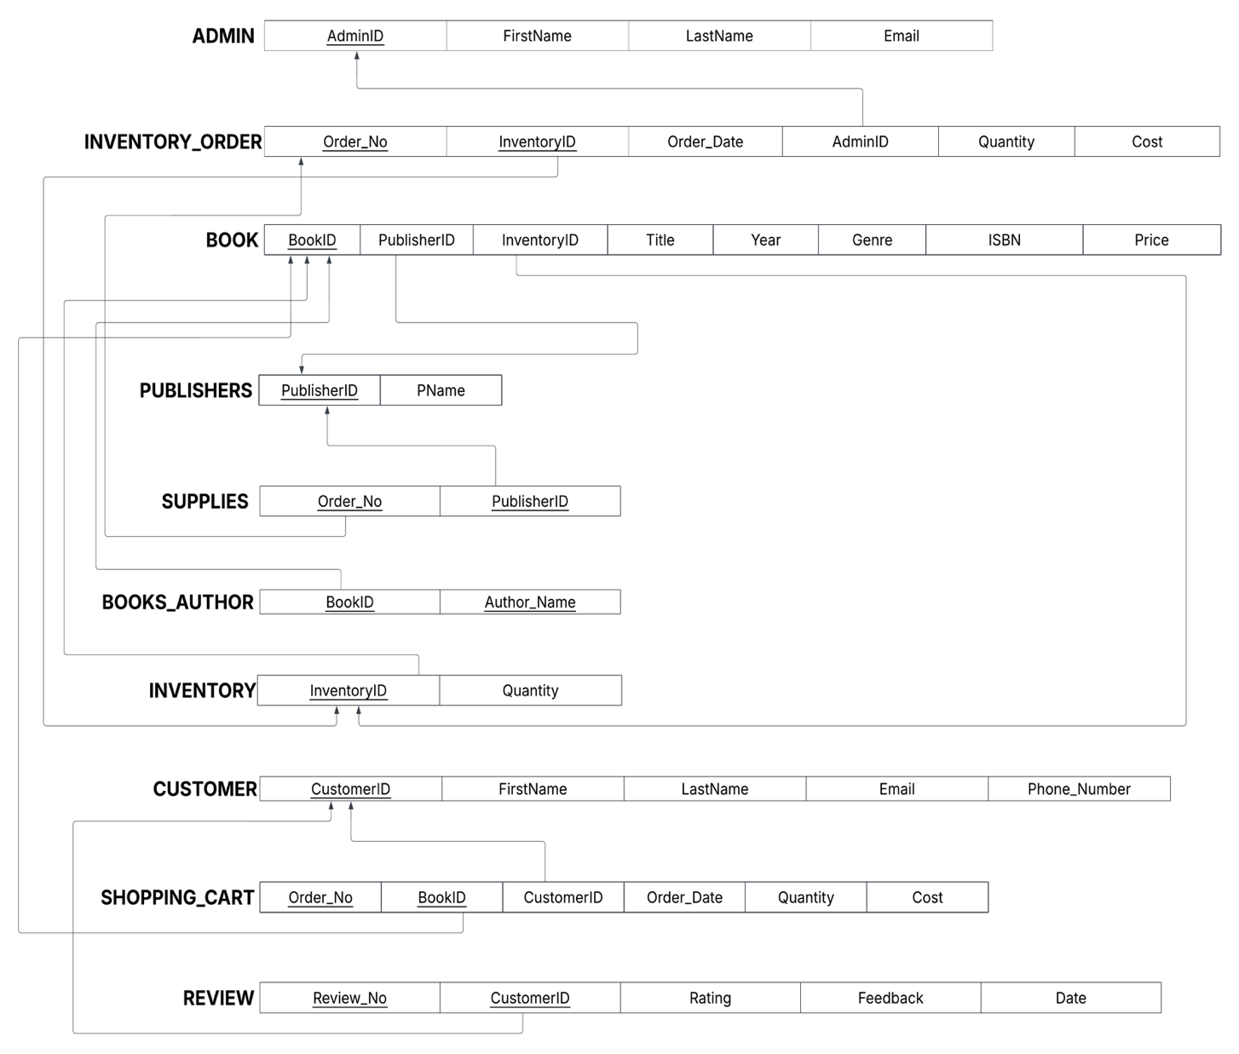
- For each relation schema in your model, indicate the functional dependencies. Think carefully about what you are modeling here - make sure you consider all the possible dependencies in each relation and not just the ones from your primary keys. For example, a customer’s credit card number is unique, and so will uniquely identify a customer even if you have another key in the same table (in fact, if the customer can have multiple credit card numbers, the dependencies can get even more involved).
- Admin Relation: (Multiple people cannot have the same Email, so it is a candidate key}
{AdminID} -> {FirstName, LastName, Email}
{Email} -> {AdminID, FirstName, LastName}
- Inventory_Order Relation:
{Order_No, InventoryID} -> {Order_Date, AdminID, Quantity, Cost}
{Order_No} -> {AdminID}
- Book Relation:
{BookID} -> {PublisherID, InventoryID, Title, Year, Genre, ISBN, Price}
{InventoryID} -> {BookID,PublisherID, Title, Year, Genre, ISBN, Price}
{ISBN} -> {BookID,InventoryID, PublisherID, Title, Year, Genre, Price}
- Publishers Relation:
{PublisherID} -> {PName}
- Books_Author Relation:
{BookID} -> {Author_Name}
- Customer Relation: (Multiple cannot have the same Email or Phone Number, so they are candidate keys)
{CustomerID} -> {FirstName, LastName, Email, Phone_Number}
{Email} -> {CustomerID, FirstName, LastName, Phone_Number}
{Phone_Number} -> {CustomerID, FirstName, LastName, Email}
- Review Relation:
{Review_No, CustomerID} -> {Rating, Feedback, Date}
- Shopping_Cart Relation:
{Order_No, BookID} -> {CustomerID, Order_Date, Quantity, Cost}
{Order_No} -> {CustomerID}
- Inventory Relation:
{InventoryID} -> {Quantity}
- Supplies Relation:
{Order_No} -> {PublisherID}
New Schema:
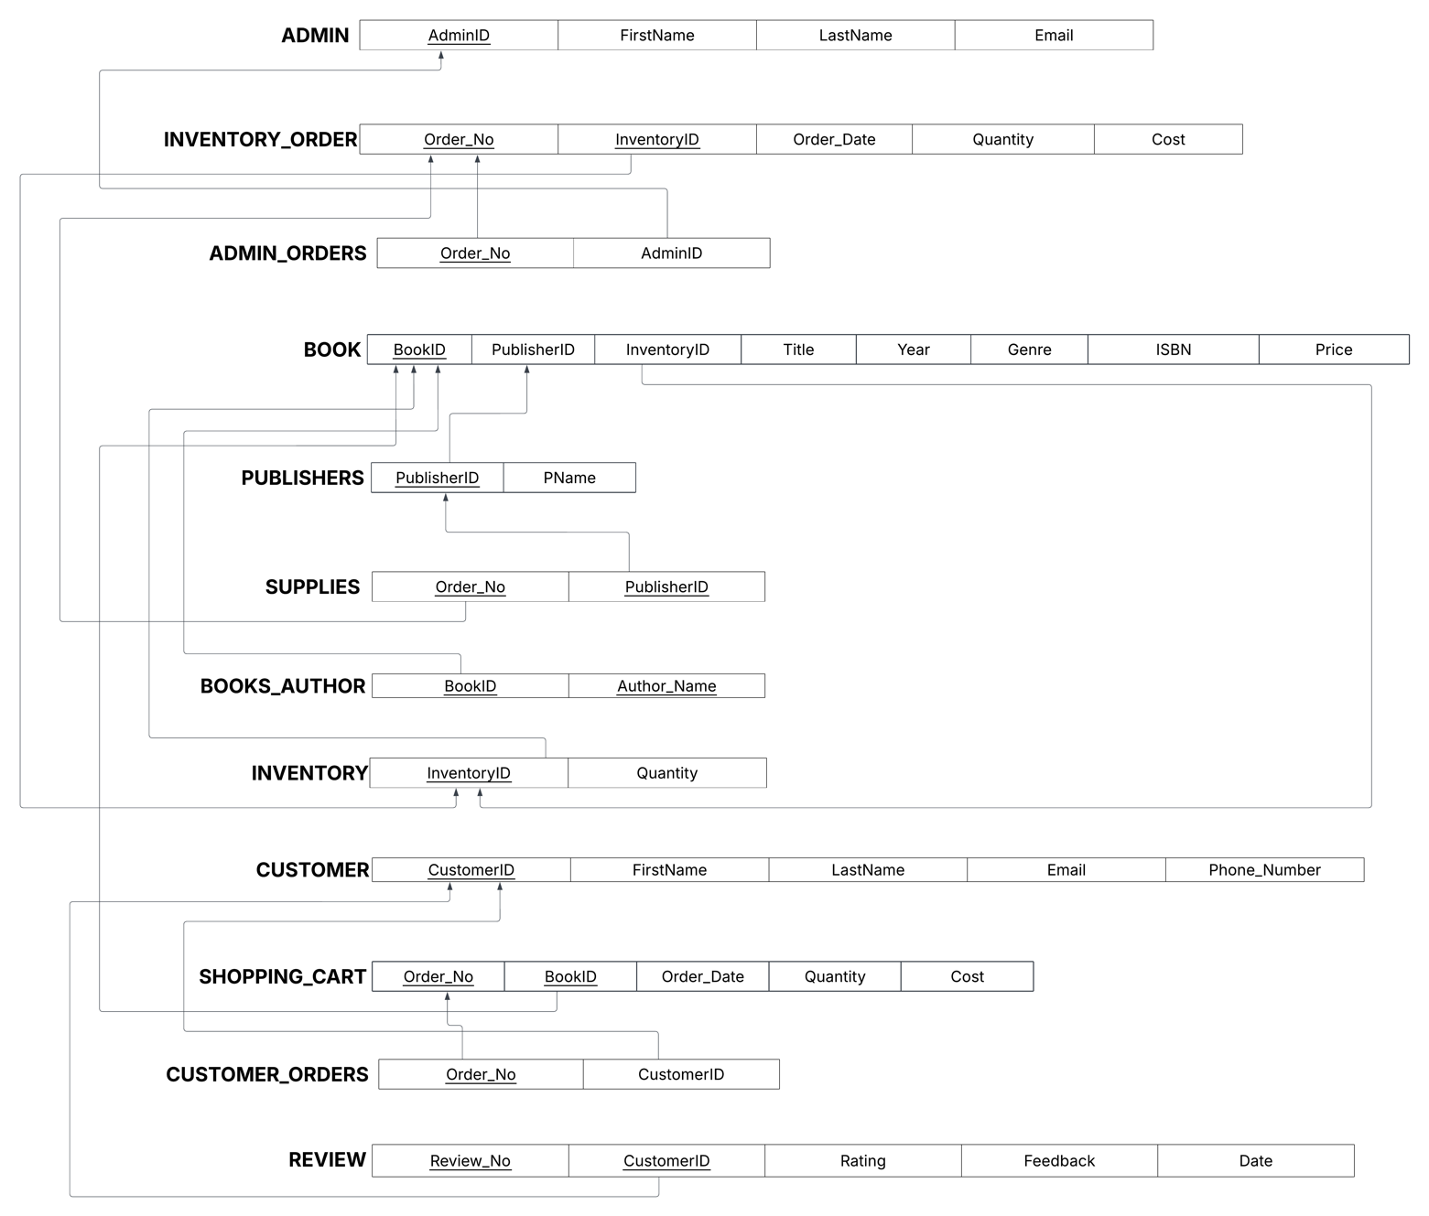
- For each relation schema in your model, determine the highest normal form of the relation. If the relation is not in 3NF, rewrite your relation schema so that it is in at least 3NF.

Apart from the Shopping_Cart and Inventory_Order relations, all relations are in 3NF.
- For the Shopping_Cart relation there is a partial dependency of CustomerID on the Order_No. A separate relation is needed for Order_No and CustomerID. An additional relation CUSTOMER_ORDERS(Order_No^{(FK)}, CustomerID^{(FK)}) was added to the schema
- For the Inventory_Order relation there is a partial dependency of AdminID on the Order_No. A separate relation is needed for Order_No and AdminID. An additional relation ADMIN_ORDERS(Order_No^{(FK)}, AdminID^{(FK)}) was added to the schema

- For each relation schema in your model that is in 3NF but not in BCNF, either rewrite the relation schema to BCNF or provide a short justification for why this relation should be an exception to the rule of putting relations into BCNF.
Each relational schema in our model is in BCNF.

All relations are in BCNF.

- For your database, propose at least two interesting views that can be built from your relations. These views must involve joining at least two tables together each and must include some kind of aggregation in the view. Each view must also be able to be described by a one or two sentence description in plain English. Provide the code for constructing your views along with the English language description of what the view is supposed to be providing.
View 1: Customer Orders - This view records the total amount spent by each customer in the bookstore. Provides information about frequent customers.
CREATE VIEW Customer_Orders_Total AS
SELECT CUSTOMER.CustomerID, CUSTOMER.FirstName, CUSTOMER.LastName, CUSTOMER.Email, COUNT(SHOPPING_CART.Order_No) AS Total_Orders , SUM(SHOPPING_CART.Cost) AS TotalSpent
FROM CUSTOMER_ORDERS
JOIN SHOPPING_CART ON CUSTOMER_ORDERS.Order_No = SHOPPING_CART.Order_No
JOIN CUSTOMER ON CUSTOMER.CustomerID = CUSTOMER_ORDERS.CustomerID
GROUP BY CUSTOMER_ORDERS.CustomerID
View 2: Customer Reviews - This view displays the average rating per customer and total number of ratings they have posted. Includes customer information. This provides information about customer satisfaction and a contact point for customers that have not had a good experience.
CREATE VIEW Customer_Reviews AS
SELECT CUSTOMER.FirstName, CUSTOMER.LastName, CUSTOMER.Email, COUNT(REVIEW.Review_No), AVG(REVIEW.Rating)
FROM CUSTOMER
JOIN REVIEW ON CUSTOMER.CustomerID = REVIEW.CustomerID
GROUP BY CUSTOMER.CustomerID;

